Written Report – 6.419x Module 3
Name: (Vikhyaat)
- Problem 1
(3 points) Plot the periodic signal . (Your plot should have 1 data point for each month, so 12 in total.) Clearly state the definition the , and make sure your plot is clearly labeled.
Solution:
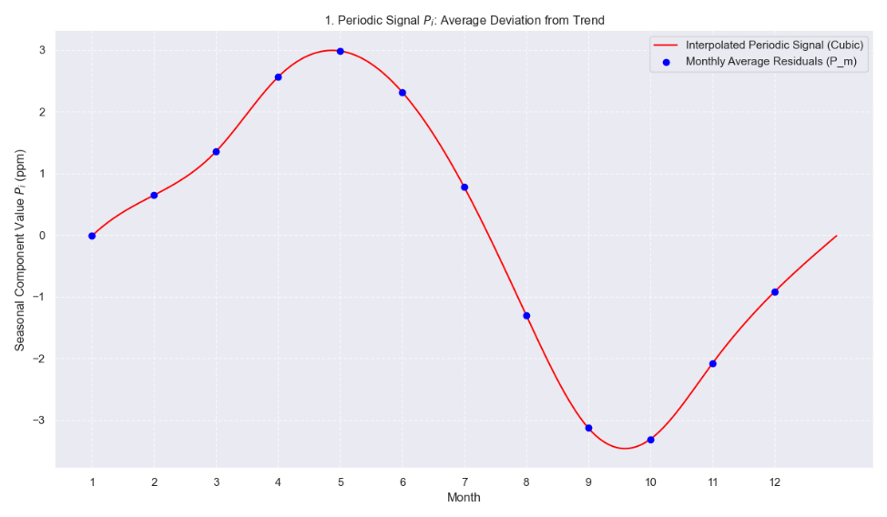

(2 points) Plot the final fit . Your plot should clearly show the final model on top of the entire time series, while indicating the split between the training and testing data.
Solution:
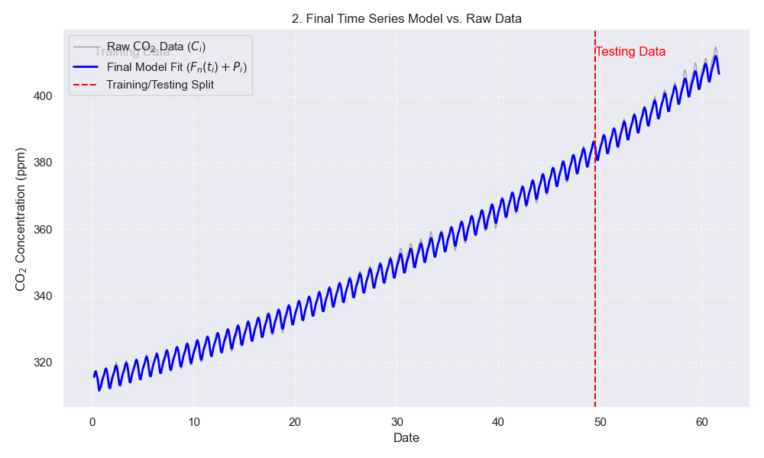
(4 points) Report the root mean squared prediction error and the mean absolute percentage error with respect to the test set for this final model. Is this an improvement over the previous model without the periodic signal? (Maximum 200 words.)
Solution RMSE with the quadratic fit without periodic term is :2.5013322194897865
MAPE :0.005320319129740861
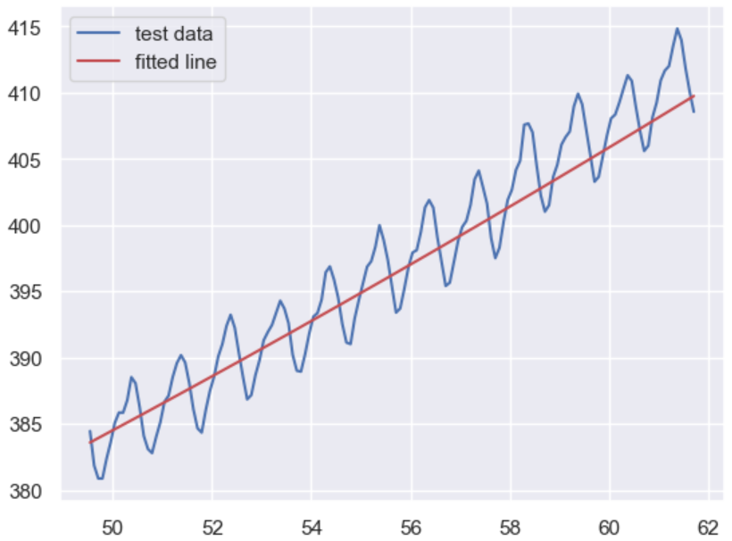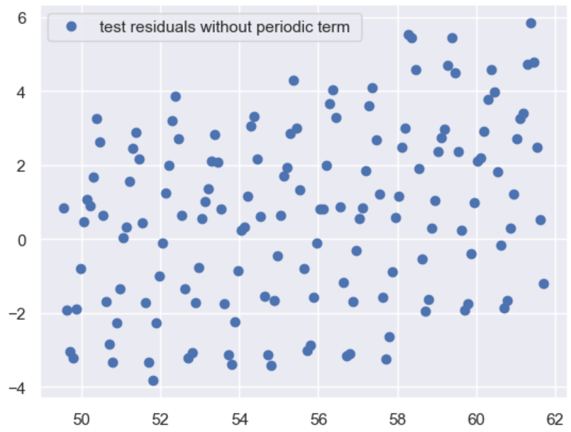

RMSE with quadratic as well as periodic fit : 1.1493602690794475
MAPE :0.0020859165947991125

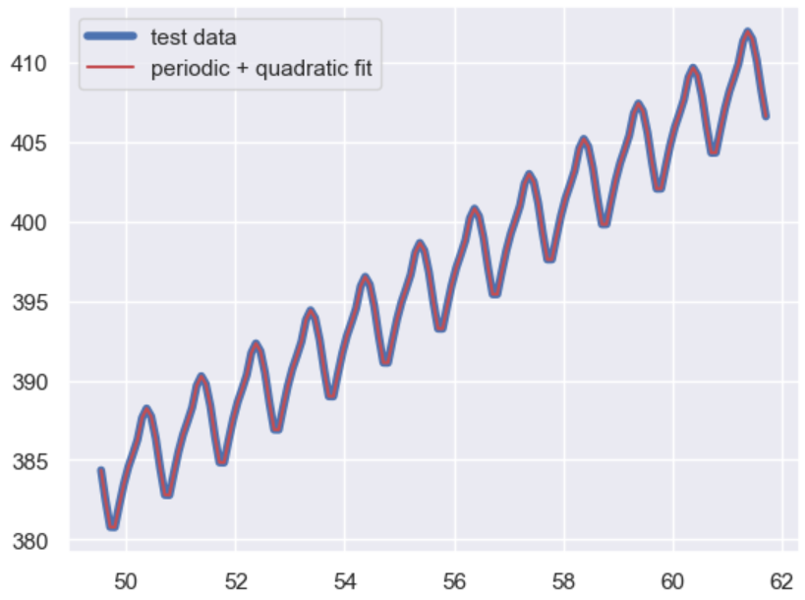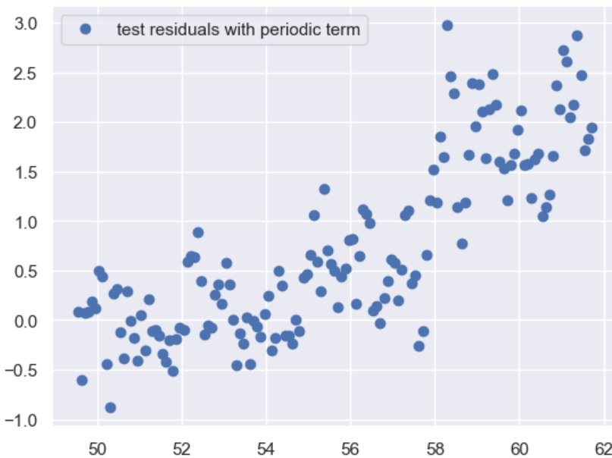

(3 points) What is the ratio of the range of values of to the amplitude of and the ratio of the amplitude of to the range of the residual (from removing both the trend and the periodic signal)? Is this decomposition of the variation of the CO concentration meaningful? (Maximum 200 words.)
Solution :
--- ANALYSIS OF VARIATION DECOMPOSITION (Q4) ---

Range of Trend (F): 95.471 ppm
Amplitude of Periodic Signal (Pi): 6.292 ppm
Range of Final Residual (Ri): 4.716 ppm

Ratio 1 (Range of F / Amplitude of Pi): 15.172
Ratio 2 (Amplitude of Pi / Range of Ri): 1.334

[Q4 Discussion]

The first ratio (Range of F / Amplitude of Pi) is 15.172. Since this value is significantly greater than 1, it indicates that the long-term, **deterministic trend (F_n(t)) dominates the overall variation** of the CO2 data over the period studied. The trend accounts for approximately 15 times the magnitude of the seasonal variation.

The second ratio (Amplitude of Pi / Range of Residual Ri) is 1.334. Since this ratio is greater than 1, the **periodic signal (Pi) is the dominant source of short-term variation** compared to the remaining random noise (Ri). Specifically, the seasonal cycle is about 1 times smaller than the range of the unmodeled error.

**Conclusion on Meaningfulness:** This decomposition is **highly meaningful**. It successfully partitions the total variation into three distinct, important components: a dominant long-term increase (Trend F), a strong, predictable annual cycle (Periodic Signal Pi), and a small, relatively insignificant random error (Residual Ri). The high value of the second ratio confirms that the chosen periodic component has successfully extracted the major deterministic fluctuation from the residuals, leaving very little unmodeled structure.

1.(4 points) Consider MA(1) the model, Xt​=Wt​+θWt−1​ where $\{W_{t}\}$is white noise:
$$W_{t}∼N(0,σ^{2}),$$
Find the autocovariance function of {X_t}.

Include all important steps of your computations in your report.
Solution:

We want the autocovariance function:
$$γ(k)=\text{Cov}(X_{t},X_{t-k})=E[(X_{t}-μ)(X_{t-k}-μ)]$$
Since $E[W_{t}]=0$, $E[X_{t}]=0$, so:
$$γ(k)=E[X_{t}X_{t-k}]$$
1. Compute $γ(0)$
$$γ(0)=\text{Var}(X_{t})=E[X_{t}^{2}]$$
Substitute:
$$X_{t}=W_{t}+θW_{t-1} \\ X_{t}^{2}=(W_{t}+θW_{t-1})^{2}=W_{t}^{2}+2θW_{t}W_{t-1}+θ^{2}W_{t-1}^{2}$$
Take expectations:
- $E[W_{t}^{2}]=σ^{2}$
- $E[W_{t-1}^{2}]=σ^{2}$
- $E[W_{t}W_{t-1}]=0$(white noise, uncorrelated)
Thus:
$$γ(0)=σ^{2}+θ^{2}σ^{2}=σ^{2}(1+θ^{2})$$

2. Compute $γ(1)$
$$γ(1)=E[X_{t}X_{t-1}]$$
Write both terms:
$$X_{t}=W_{t}+θW_{t-1} \\ X_{t-1}=W_{t-1}+θW_{t-2}$$
So:
$$X_{t}X_{t-1}=(W_{t}+θW_{t-1})(W_{t-1}+θW_{t-2})$$
Expand:
$$=W_{t}W_{t-1}+θW_{t}W_{t-2}+θW_{t-1}^{2}+θ^{2}W_{t-1}W_{t-2}$$
Take expectations:
- $E[W_{t}W_{t-1}]=0$
- $E[W_{t}W_{t-2}]=0$
- $E[W_{t-1}^{2}]=σ^{2}$
- $E[W_{t-1}W_{t-2}]=0$
Thus:
$$γ(1)=θσ^{2}$$

3. Compute $γ(k)$for $∣k∣>1$
If $k>1$, $X_{t}$and $X_{t-k}$share no common white noise terms, so:
$$γ(k)=0\text{for }∣k∣>1$$

Final Autocovariance Function
$$\boxed{γ(k)=\{\begin{matrix}σ^{2}(1+θ^{2}), & k=0 \\ θσ^{2}, & ∣k∣=1 \\ 0, & ∣k∣>1\end{matrix}}$$
This is the standard result for a stationary MA(1) process.

2.(4 points) Consider AR(1) model, Xt​=ϕXt−1​+Wt​
where:
- $W_{t}∼N(0,σ^{2})$is white noise
- $∣ϕ∣<1$so the process is stationary
. Find the autocovariance function of {X_t}.

Solution:
We want the autocovariance function:
$$γ(k)=\text{Cov}(X_{t},X_{t-k})$$

1. Mean of $X_{t}$
Since $E[W_{t}]=0$, and in a stationary AR(1) process,
$$E[X_{t}]=0$$
Thus,
$$γ(k)=E[X_{t}X_{t-k}]$$

2. Compute $γ(0)$
$$γ(0)=\text{Var}(X_{t})$$
Start with the model:
$$X_{t}=ϕX_{t-1}+W_{t}$$
Square both sides and take expectation:
$$E[X_{t}^{2}]=E[(ϕX_{t-1}+W_{t})^{2}]$$
Expand the square:
$$=ϕ^{2}E[X_{t-1}^{2}]+2ϕE[X_{t-1}W_{t}]+E[W_{t}^{2}]$$
Since white noise is independent of past values:
$$E[X_{t-1}W_{t}]=0$$
And:
$$E[W_{t}^{2}]=σ^{2}$$
Thus:
$$γ(0)=ϕ^{2}γ(0)+σ^{2}$$
Solve for $γ(0)$:
$$γ(0)(1-ϕ^{2})=σ^{2} \\ \boxed{γ(0)=\frac{σ^{2}}{1-ϕ^{2}}}$$

3. Compute $γ(1)$
$$γ(1)=\text{Cov}(X_{t},X_{t-1})=E[X_{t}X_{t-1}]$$
Substitute the model:
$$X_{t}=ϕX_{t-1}+W_{t}$$
So:
$$γ(1)=E[(ϕX_{t-1}+W_{t})X_{t-1}] \\ =ϕE[X_{t-1}^{2}]+E[W_{t}X_{t-1}]$$
Again, $W_{t}$is independent of $X_{t-1}$, so:
$$E[W_{t}X_{t-1}]=0$$
Thus:
$$γ(1)=ϕγ(0)$$
So:
$$\boxed{γ(1)=ϕ\frac{σ^{2}}{1-ϕ^{2}}}$$

4. General $γ(k)$
Using the property of AR(1):
$$γ(k)=ϕγ(k-1)$$
By recursion:
$$\boxed{γ(k)=ϕ^{k}γ(0)}$$
Substituting our value of $γ(0)$:
$$\boxed{γ(k)=\frac{σ^{2}}{1-ϕ^{2}}ϕ^{k}}\text{for }k=0,1,2,…$$
By symmetry:
$$\boxed{γ(-k)=γ(k)}$$

Final Answer
The autocovariance function of the AR(1) process is:
$$\boxed{γ(k)=\frac{σ^{2}}{1-ϕ^{2}}ϕ^{∣k∣}}$$

Problem 2

1.Repeat the model fitting and evaluation procedure from the previous page for the monthly inflation rate computed from .

Your response should include:

(1 point) Description of how you compute the monthly inflation rate from CPI and a plot of the monthly inflation rate. (You may choose to work with log of the CPI.)
Solution: The code df_monthly = df_daily['CPI'].resample('MS').mean() aggregates daily "CPI" (Consumer Price Index) data into monthly averages, with each month labeled by its start date. Monthly inflation rate was calculated by taking log of the ratio of CPI at t and t-1.
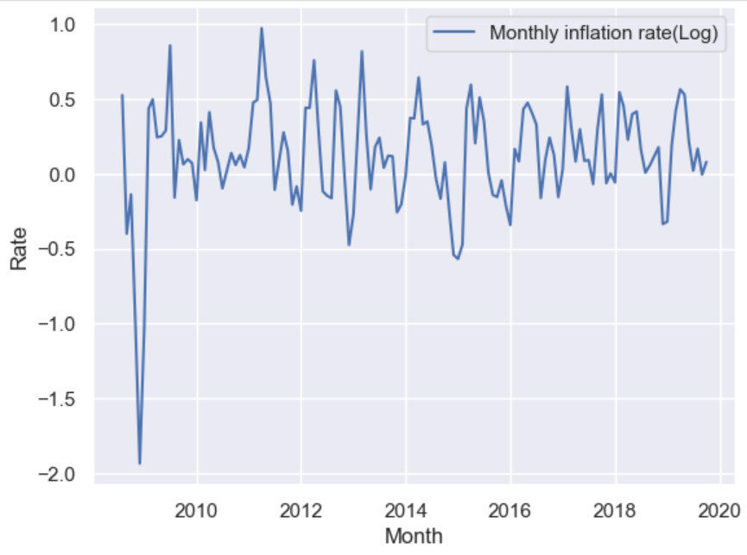

(2 points) Description of how the data has been detrended and a plot of the detrended data.
Solution: A linear model was fit and subsequently subtracted to yield a detrended dataset.
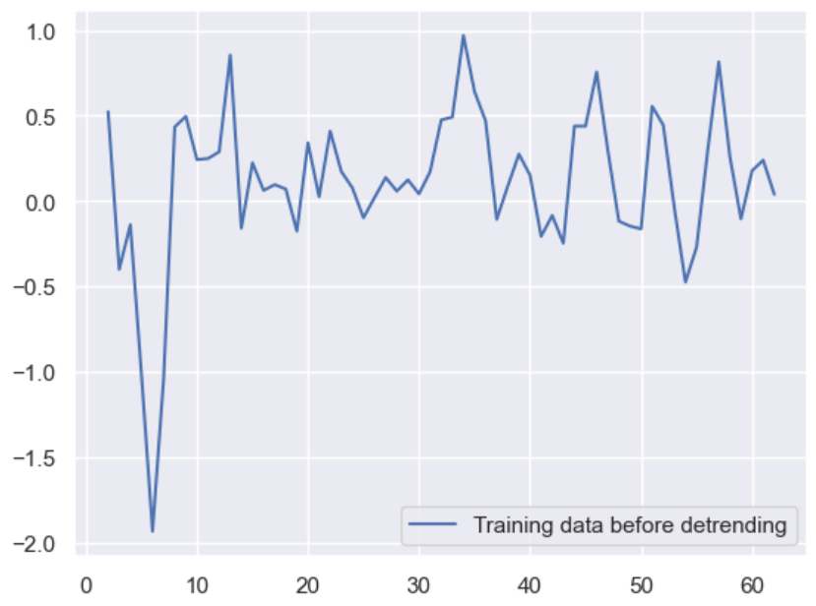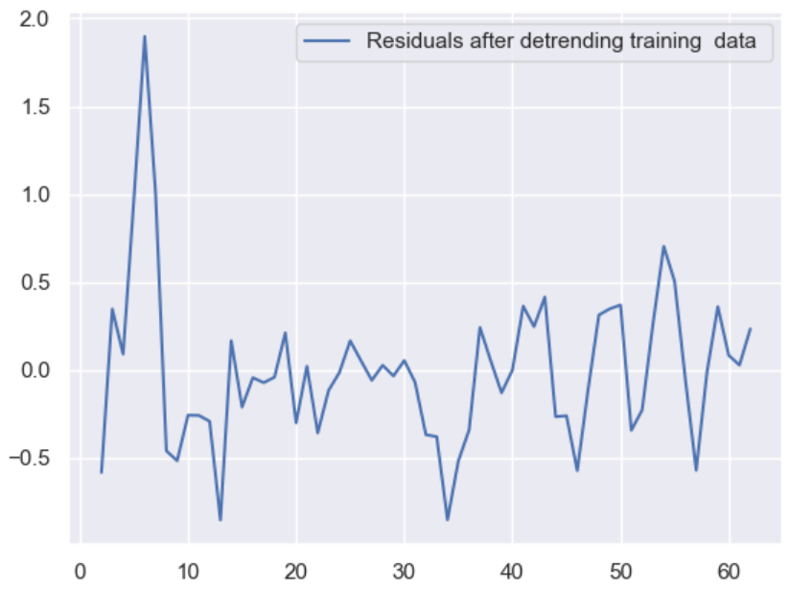

(3 points) Statement of and justification for the chosen AR(p) model. Include plots and reasoning.
Solution:
AR(1) model was chosen because pacf drops to zero after 1st lag
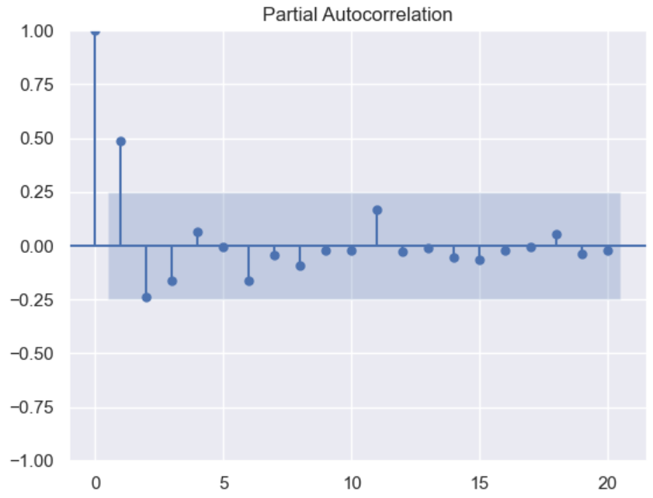

(3 points) Description of the final model; computation and plots of the 1 month-ahead forecasts for the validation data. In your plot, overlay predictions on top of the data.
Solution:
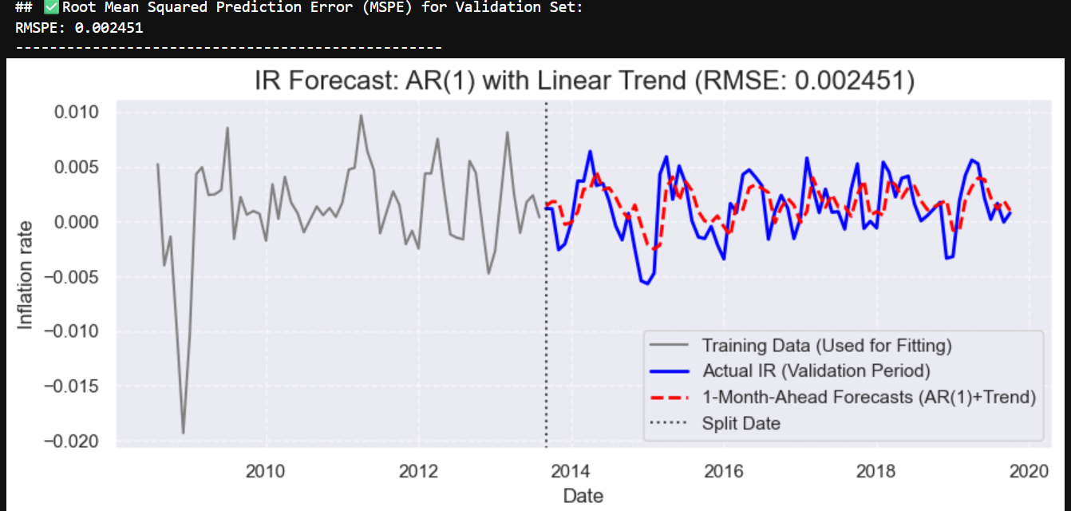

2.(3 points) Which AR(p) model gives the best predictions? Include a plot of the RMSE against different lags p for the model
Solution: Best AR model based on minimum RMSE is AR(2) with RMSE : 0.0024

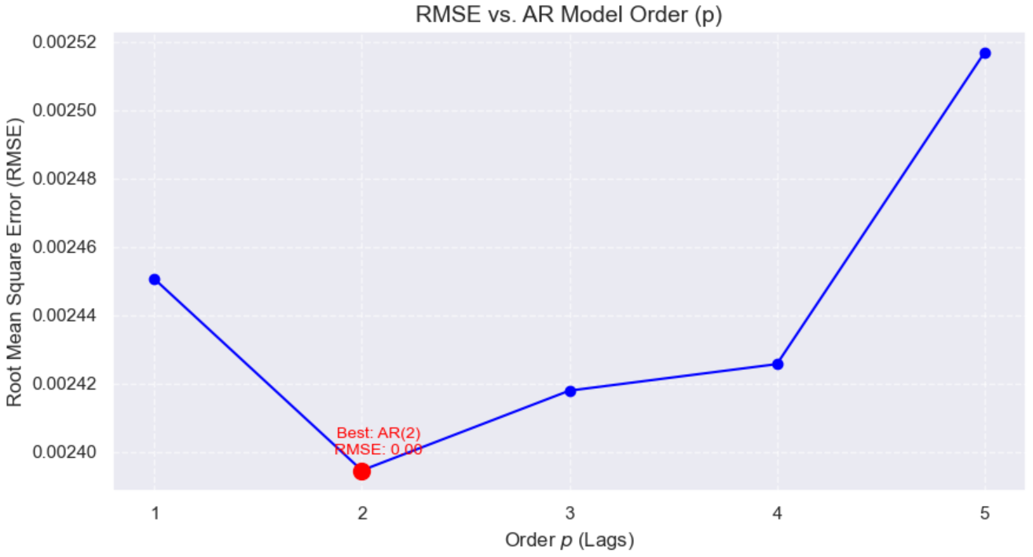

(3 points) Overlay your estimates of monthly inflation rates and plot them on the same graph to compare. (There should be 3 lines, one for each datasets, plus the prediction, over time from September 2013 onward.)
Solution:
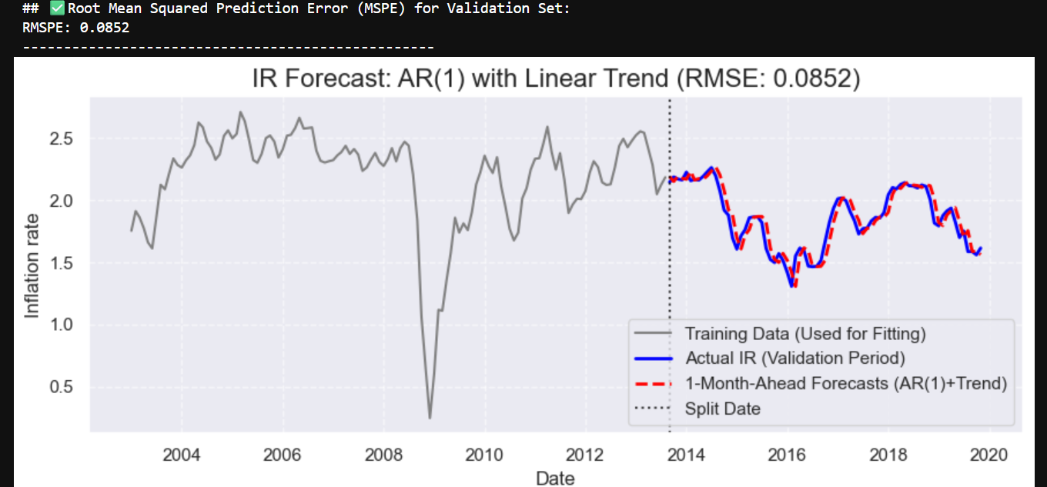

Part 2

1.(4 points) Plot the cross correlation function between the CPI and BER inflation rate, by which find , i.e., the lag between two inflation rates. (As only one external regressor term is involved in the model, we only consider the peak in the CCF plot.
Solution:
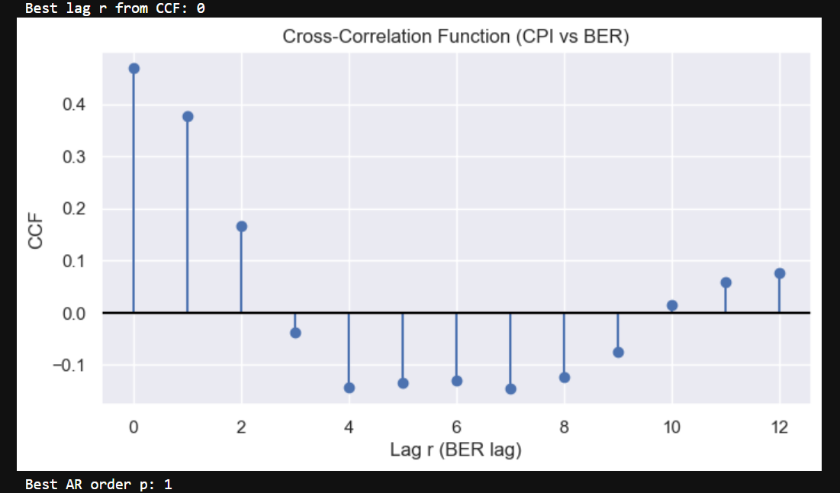

2.(3 points) Fit a new AR model to the CPI inflation rate with these external regressors and the most appropriate lag. Report the coefficients, and plot the 1 month-ahead forecasts for the validation data. In your plot, overlay predictions on top of the data.
Solution:
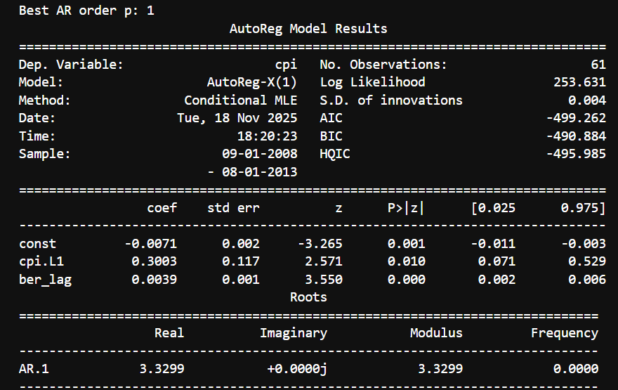
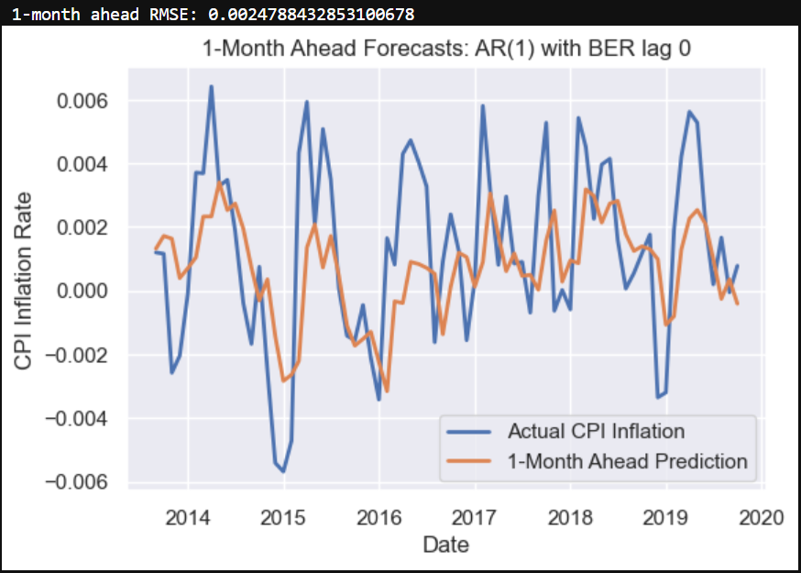

3.(3 points) Report the mean squared prediction error for 1 month ahead forecasts.
Solution:
0.0025 which is not very different from one without external regressor 0.0024

(5 points) What other steps can you take to improve your model from part III? What is the smallest prediction error you can obtain? Describe the model that performs best. You might consider including MA terms, adding a seasonal AR term, or adding multiple daily values (or values from different months) of data as external regressors.
Solution: I tested various combinations of SARIMA model parameters which include the non-seasonal orders (\(p,d,q\)) and the seasonal orders (\(P,D,Q,S\)), where \(p\) is the autoregressive order, \(d\) is the differencing order, and \(q\) is the moving average order. The seasonal component is defined by \(P\), the seasonal autoregressive order;\(D\), the seasonal differencing order;\(Q\), the seasonal moving average order; and \(S\), the number of time steps for each seasonal cycle. Best non seasonal order is with 1 AR term and 1 MA term :(1,0,1) Best seasonal order is: (1,0,0,12).

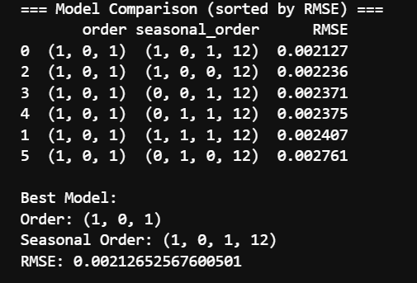

THE final forecasted values along with validation and training data:
